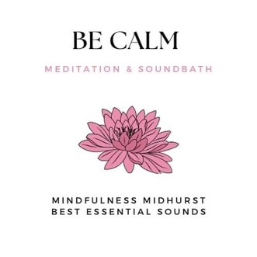
Mindfulness and Sound Bath
Booking Form

To register please answer this questionnaire. The information you give is strictly confidential and will only be seen by Claire and Sandrine. Your information is kept in a secured place for the duration of the event and will be deleted afterwards.

Name: Your phone number:
Your email:

Name and phone number of someone to contact in case of emergency:

____________________________________________________________

- Do you have any physical issues that may make sitting, standing, moving, difficult?

- Are you experiencing any mental health issues such as depression or going through any difficult life event (ie: bereavement, divorce, job loss)?

- Is there anything else that you would like us to be aware of?

- What is your experience if any, of mindfulness, meditation and sound bath?

- Do you have any food allergies (I.e. fruit, raisins, chocolate) for the mindful eating practice:

- Because of the nature of sound penetrating the cells of the body, there are certain contra-indications in receiving a sound bath. Please state if you have any of the following, so we can modify.
- In your 1st trimester of pregnancy
- Have sound-induced epilepsy
- Severe mental health issues, psychosis or any other mental health challenges
- Heart conditions – arrhythmia, pacemaker, stent, shunt
- Neurological shunt, implanted electrical device in brain
- Undergoing cancer treatment

7. Where did you hear about this wellbeing event?

To book:
- Please return completed booking form to:
sb.cranswick@gmail.com and clairenbest@hotmail.com
- Please pay £90 by bank transfer (details in the practical information PDF) or £92 by PayPal using the booking calendar (scroll down to the calendar, click on 15 September and select the course “Be Calm”)

Please don’t hesitate to contact us by email if you have any questions or concerns.
We look forward to welcoming you!
Sandrine and Claire

